# Dissertation Outline

## Outline with Flatau

1. Motivation (why do we need this study?)
   1. Magnetostriction
      1. Description of magnetostriction from SUSCHEM proposal
         1. **Magnetostriction** is the structural response of magnetic materials to an external magnetic field, which arises due to the dependence of the magnetocrystalline anisotropy energy on strain. The magnetostrictive coefficient , which is the ratio of the magnetoelastic coupling *b* to the shear modulus ( = *b/C'*), serves as a figure of merit for magnetostrictive performance. Magnetostriction in Terfenol-D can be traced back to the strong spin-orbit (magnetoelastic) coupling of the lattice to the anisotropic electron cloud surrounding the Tb ion. The understanding of magnetostriction in Galfenol is more challenging, because spin-orbit coupling is generally weaker in the 3d transition metals and the electron cloud surrounding the Fe ion is more deformable than for Tb or other rare-earth ions. Although some extrinsic origins have been proposed,[1],[2] it is believed that the enhanced magnetostrictive response of Galfenol results from intrinsic factors, namely, changes in the electronic structure due to Ga ordering. For Galfenol and several related alloys with low Ga concentrations (0% < *x* < 14%), DFT calculations performed with the correct, experimentally observed ordered structures can satisfactorily reproduce the experimental dependence of λ001 on alloy composition as shown in Fig. 5. When dealing with real alloys with varying degrees of chemical order, we used AIMD for the determination of structures in a reasonably large supercell, and the trend of magnetostriction around *x*=19% can also be captured. Similar to the auxetic properties of Galfenol, growth of the magnetostriction can be explained, in part, by growing elastic anisotropy and the softening of the shear modulus, *C'*. However, the evolution of magnetoelastic coupling with composition is equally important. With the complete quantum mechanical information, we traced the origin of largely enhanced magnetostriction to individual atoms and pairs of electronic states. In particular, the local short range ordering such as the formation of B2 and D03 coordinates becomes an extremely important factor in the magnetostriction at high Ga concentrations. We expect that the composition ratios and atomic arrangements in the surface and interface regions differ from that in the bulk and can be modified with the exposure to different gases during high temperature anneal.

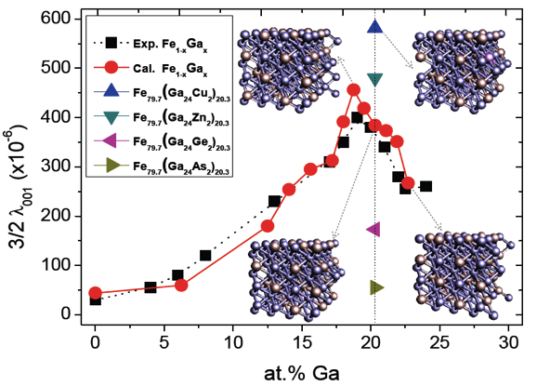Fig. 5. Calculated tetragonal magneto- striction constant (3/2)λ001 (red circles) and experimental data taken at room temperature (black squares at different Ga concentrations). Triangles show results of four ternary alloys with addition of Cu, Zn, Ge and As. Insets give the crystal structures with purple and red balls for Fe and Ga atoms, respectively.

* + 1. Brief explanation of magnetostriction basics
       1. Physics
       2. How to detect magnetostriction?
          1. Hall effect sensors

A transducer that varies its output voltage in response to a magnetic field using the **Hall Effect**.

Electrical characterizationof materials evolved in three levels of understanding. In the early 1800s, the resistance *R* and conductance *C* were treated as measurable physical quantities obtainable from two-terminal *I-V* measurements (i.e., current *I*, voltage *V*). Later, it became obvious that the resistance alone was not comprehensive enough since different sample shapes gave different resistance values. This led to the understanding that an intrinsic material property like resistivity (or conductivity) is required that is not influenced by the particular geometry of the sample. For the first time, this allowed scientists to quantify the current-carrying capability of a material and carry out meaningful comparisons between different samples.

By the early 1900s, it was realized that resistivity was not a unique material parameter, since different materials can have the same resistivity. Also, a given material might exhibit different values of resistivity depending upon how it was synthesized. This is especially true for semiconductors where resistivity alone could not explain all observations. Theories of electrical conduction were constructed with varying degrees of success, but until the advent of quantum mechanics, no generally acceptable solution to the problem of electrical transport was developed. This led to the definitions of carrier density *n* and mobility *μ* (third level of understanding), which are capable of dealing with even the most complex electrical measurements today.

The basic physical principle underlying the Hall Effect is the Lorentz force. When an electron moves in an applied magnetic field, it experiences a force acting normal to both directions and moves in response to this force. For *n*-type, bar-shaped semiconductors like the one shown in Figure 1, the carriers are predominately electrons of bulk density *n*.

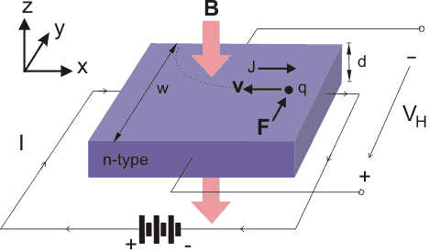

Figure 1: This figure shows the standard geometry for a Hall Effect measurement.

We assume that a uniform current *I* flows along the x-axis from left to right in the presence of a z-directed magnetic field. Electrons subject to the Lorentz force initially drift away from the current line toward the negative y-axis, resulting in an excess surface electrical charge on the sides of the sample. This charge results in a voltage across the two sides of the sample, which is called the Hall voltage, *VH*. (Note that the force on holes is toward the same side because they would move in the opposite direction, and due to their positive charge.) The magnitude of the Hall voltage is equal to

$$V_{H}=\frac{IB}{qnd}=R_{H}\frac{IB}{d} (1)$$

where *I* is the current passing through the probe, *B* is the magnetic field, *d* is the sample thickness, *n* is the carrier density, and *q* ( $1.602 × {10}^{-19}$ C) is the elementary charge. *RH* is the Hall coefficient which equals $1/{qn}$.

In a doped semiconductor, the crystal is contaminated by doping with an impurity. If the doping material has one more valence electron than the base material, an n-type semiconductor is produced. Consider the case of germanium doped with arsenic: the energy levels of the outer electrons in the arsenic are slightly different from those in germanium and find themselves just below the conducting band. As a result, arsenic electrons can be displaced into the conducting band without leaving holes in the valence band. Therefore, electrons predominate as the charge carrier in these substances. Charge carriers that result from doping are known as extrinsic carriers. Over the temperature range in which extrinsic conduction predominates, the resistance of the semiconductor rises with temperature, just as it does in conductors. Once intrinsic conduction becomes important, the resistivity falls with rising temperature, due to the increase in the number of charge carriers.

The Hall voltage is essentially independent of temperature over the extrinsic conduction range when current is held constant. When intrinsic conduction dominates, the Hall voltage falls as temperature rises. This is because both charge carriers are created in equal numbers.

* + - 1. Magnetic stray fields from the surface of magnetostrictive materials
      2. Applications from group
         1. Whiskers for scour detection
         2. Contactless torque sensing

Ganesh paper

Whiskers are biologically inspired by mystacial vibrissae on the hair cells on fish lateral lines and spider legs.[1]

* + - * 1. Energy harvesting

From UMERC Wells proposal

Energy harvesting from ambient vibrations has the potential to bring battery-free wireless electronics to fruition in the commercial sector. In vehicles, a tire pressure monitoring system equipped with the harvester can be operated without a button cell by using vibrations from the engine as power source. Self-powered autonomous wireless sensor systems can notify factories of structure or machine abnormalities without the need of external power or the hassle of battery replacement. The technology will also be applicable for battery-free remotes used in home automation by pushing a button to send on-off infrared signals, or powering hallway lights from floor vibrations as someone walks. Vibrational energy harvesters can work in conjunction with high capacitance devices, supercapacitors, for energy storage undergoing frequent charge and discharge cycles at high current and short duration, like a portable, self-charging cell phone charger. Technologies that convert vibrational energy into electrical power include piezoelectric materials[2], electromagnetic induction[3], and magnetostrictives[4].

There are few commercial energy harvesters being used effectively as barriers to widespread implementation exist. Specifically, piezoelectrics are brittle with poor robustness to bending and tension. They also suffer from high output impedance in the MΩ range, which is a result of their capacitive properties, that transfer only small amounts of electrical energy to external loads. In moving-magnet type harvesters, poor coupling and low resonant frequency up to several Hz results in low output voltage.

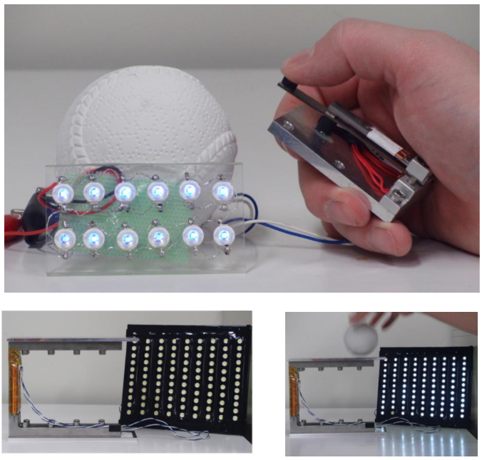

Figure : Galfenol resonant beam energy harvester. Photo courtesy of Dr. Toshiyuki Ueno, Kanazawa University, Japan. Galfenol beams are in the same region as the coils and have dimensions of 3 mm thick x 15 mm width x 80 mm length.[57]

The iron-based magnetostrictive alloy Fe-Ga (Galfenol, Fe100-xGax) is of interest for actuation, sensing and energy harvesting applications because in addition to its magnetostrictive properties, it is ductile and it has robust mechanical properties[5], relatively high permeability and good saturation magnetization (~1.7 T)[6]. These properties allow our collaborator at Kanazawa University, Toshiyuki Ueno, to prototype highly-scalable Galfenol energy harvester devices with high efficiency, high power output, and low impedance[7], as seen in Figure 1. Fe-Al (Alfenol, Fe100-xAlx) has been overlooked as an actuactor because it has about half the magnetostriction of Fe-Ga alloys. However, Fe-Al has similar saturation magnetization (~1.5 T) and similar mechanical properties to Fe-Ga, making it an attractive energy harvester with the added benefit of being more earth abundant and less expensive than Fe-Ga[8], [1].



Figure : Cartoons depicting a perfectly aligned cubic alloy with <100> magnetic easy axes as indicated. Arrows depict idealized orientation of magnetic domains.

Fe-Al is sufficiently magneto-elastic that coupling between bending stress and magnetic moment rotation yields readily observable time-varying magnetization changes in the alloy. In harvesters, power is generated in a copper coil that surrounds a magnetostrictive material when a time varying stress, e.g. vibration of the magnetostrictive material, produces a voltage in the coil (per Faraday’s law)[9]. Fe-Al is a body-centered cubic alloy textured to develop a <100> preferred orientation along the length of the strips by abnormal grain growth (AGG)[10]–[12]. The <100> directions are the magnetic easy axes. Subsequently, the stress annealing protocol was performed to introduce built-in uniaxial anisotropy perpendicular to the length of the strips[13]. This was done to maximize 90° rotation of magnetic moments when the strip bends. Successful stress-anneal-induced magnetic anisotropy was achieved, but this stress annealing process could not provide uniform compressive stress on each tested sample leading to non-uniform magnetic flux change along the strip length. As a viable alternative for a uniform magnetic flux change, Brooks et al. have used magnetic field annealing to achieve nearly identical saturation magnetostriction under compressive and no preload values[14].

Currently, stress-annealed and field-annealed samples are first rolled into sheets from ingots, and then atmospherically annealed to develop large grains that cover over 90% of the sample surface area. This process avoids lengthy and expensive single-crystal growth methods. We target Goss {110} and Cube {100} textures to obtain one and two directions, respectively, of easy magnetic axes and high magnetostriction in the plane of the rolled sheet. Goss-textured Alfenol can reach magnetostrictive constants of ~184 ppm, and the elusive Cube-textured Alfenol would reach even higher magnetostriction values due to the additional direction of easy magnetic axes. An added benefit of developing a Cube texture is that it will make feasible use of magnetic field annealing to maximize performance[13], [15] and thereby eliminate the need for stress annealing or use of pre-stress components in the design of devices that use these materials[16], [17].

* + 1. Effects of surface texture with magnetostriction
       1. Goss Textures
       2. Cube texture yields the highest magnetostrictive constant
    2. How to effect surface textures of Galfenol and Alfenol using rolling and annealing
       1. Kramer and kohler papers on surface modification
    3. Modeling so far of AGG for Galfenol and Alfenol
       1. Hyunseok’s dissertation with CSL and HEGB theories
          1. Explanation of CSL and HEGB models
          2. Do they work well to explain the grain growth on Galfenol

Gives proper description of Goss textures, but not Cube texture

* + 1. Why do we need surface energy measurements?
       1. Improve fundamental characterization of pure metals and alloys
          1. Orientation dependence at the surface
          2. Uniformity of abnormally grown grains
       2. Grow single-crystal-like iron alloys
          1. Benefits of single crystal Galfenol (FeGa)

High tensile strength, yet high ductility

Improving ultimate tensile strength by composite work

Machinable

Whisker shape

Washer shape

Nanowires

* + - * 1. Benefits of single crystal Alfenol (FeAl)

1. Surface energy literature review
   1. What is the importance of surface energy?
      1. “The field of surface thermodynamics and in particular the concept of the surface free energy was introduced by Gibbs [1,2]. The surface free energy, γ, for a one-component material is here defined as the work *dW* required to create new surface area *dA* at a constant temperature and chemical potential, γ=dW/dA. For crystalline materials it is understood that this work depends on the atomistic structure of the surface. Hence γ is in general an orientation dependent quantity for crystalline solids. For multi-component crystals the surface free energy may also be a complex function of composition. It is therefore not simply equal to γ but to the sum of γ plus the products of chemical potential and surface excess concentrations, the latter summed over all chemical components. The surface free energy and its dependence on temperature, crystallographic orientation and chemical composition is one of the most fundamental quantities in the areas of surface physics and chemistry. Likewise, it also influences processes in applied areas, e.g. those involving thin film deposition, crystal growth, or the morphological stability of nano- or microscopic artificial structures. Hence it is an important task to fully understand its fundamental physics as well as improve and develop the methods for measuring it accurately.”[18]
   2. Why do we measure surface energy on materials?
      1. Polymers
      2. Coatings
      3. Metals
   3. Survey of current surface energy techniques
      1. List
         1. Pendant drop
            1. Measures metal geometries in liquid form in vacuum
            2. High temperature surface tension for metals loses orientation-dependence due to the liquid form.[19], [20]
            3. Extrapolating surface energies at higher temperatures than the melting temperature of tested metals using simple thermodynamic theoretical considerations reach reasonable results when compared to experimental results.[21]
         2. STM
            1. Require 3D equilibrium crystal shapes (ECS) to be measured by scanning tunneling microscope.

“The structure of free solid crystallites cannot be studied because experimentally the crystallites need to be at a fixed location and in a known orientation relative to the probe. Hence all experiments are carried out for supported crystallites. The interaction between the crystallite and the support itself may disturb the shape and/or the structure of the crystallite, especially at the interface. So, if the crystallite is very small, e.g. less than 100 nm in diameter, the influence of the support can be serious. For crystallites with diameters of the order of 1 µm or more, such an influence is not expected.”[18]

Because of this size limitation, we cannot be certain that the solid crystallite with diameter < 100 nm will be the characteristic equilibrium crystal shape expected from a Wulff construction.

A Wulff Construction: a method to determine the equilibrium shape of a droplet or crystal of fixed volume inside a separate phase (usually its saturated solution or vapor). Energy minimization arguments are used to show that certain crystal planes are preferred over others, giving the crystal its shape. (Wikipedia.org)

Since Galfenol and Alfenol have bcc structures (analogous to α-Fe), Fe nanocrystals can be used as a baseline for a surface energy study by observation and analysis using scanning tunneling microscopy (STM). Unfortunately, the observed size of the nanocrystals range from 2-20 nm when grown using conventional thermal decomposition methods; In a special case, 2-nm body-centered cubic (bcc) α-Fe nanoparticles were transformed into nanorods.[22], [23] This means that an independently grown α-Fe nanocrystal or nanorod on a support will have a significant influence on the shape of the crystals, and an ECS cannot be formed to investigate absolute surface energies.

Only large nanoparticles like Pb, Cu, Sn, and Au with diameters much greater than 100 nm have been observed in their equilibrium crystal shape (ECS) form.[18], [24]

* + - 1. Sessile drop
    1. Why they are used
       1. Fundamental questions
       2. Ease of use
       3. Wettability
          1. Microelectronics
          2. Hydrophobic coatings
          3. Porosity
          4. Capillary effect in porous materials
    2. Why they do not meet our research needs

1. Gallium drop method basics
   1. Derivation of concept
      1. Thermodynamic equilibrium argument
      2. Thermal expansion of substrate
         1. Change temperature -> change contact angle
   2. Experimental setup
      1. Inert atmosphere
      2. Changing temperature
      3. Single crystal-like samples
      4. Pure gallium liquid
2. Gallium drop method results
   1. Experimental iterations
      1. Plexiglass box in radiation chamber
      2. Glass box in radiation chamber
      3. Aluminum enclosure
         1. High resolution camera
         2. Heat tape for conductive thermal control
3. Future experiments
   1. Schultz method (Two-liquid-phase-method)
      1. Derivation
      2. Use in recent literature
   2. Wenzel and Cassie models (Pillared metal surface)
      1. Used to get a more robust contact angle measurement by patterning a surface with your desired roughness geometry, as opposed to a supposedly flat yet randomly rough surface by physical polishing methods.
      2. Microfabrication steps
         1. How to pattern the surface?
            1. Some inert coating?

Transparency for spacings >40 microns

Quick masking process that uses a high resolution printer

Inexpensive

Chrome mask for spacings <40 microns

Can be very expensive to send in to companies

* + - 1. How to etch the surface?
         1. Chemical etching

<http://www.cleanroom.byu.edu/selective_chemical.pdf>

* + 1. Potential problems
       1. Will the roughness of the surfaces dominate the contact angle made by water in the n-alkanes?
       2. Will there be a change in the contact angle with orientation

## Literature Review

### Magnetostriction review

We know from class that unpaired electrons in the valence shell, hence unbalanced spins, can produce significant magnetism in an atom. However, these electrons are used in bonding when forming a solid making their contribution to magnetism in a solid is negligible[25]. The preserved magnetic moments in solids are more characteristic of an element’s ionic electron configuration (Fe3+ rather than Fe) or with sufficient bonding electrons added to complete the shell. The only groups of elements in the periodic table which exhibit magnetic moments in solids are those in which the unbalanced electron populations occur in an *inner* shell, namely the transition metals (3*d*, 4*d*, and 5*d*), rare earths (4*f*), and actinides (5*f*). It is clear that the more tightly bound an unfilled orbital shell is, the less the unpaired electrons will have to do with bonding and the more they will contribute to magnetism. This is why we see very strong magnetic responses in rare earth materials which use 6*s* and 5*d* shells for bonding before using the very tightly bound 4*f* shell electrons. The 3*d* electrons in transition metals are less tightly bound to the nucleus, and sometimes 3*d* electrons are used for bonding.

Magnetoelasticity is the coupling between a material’s classical properties of elasticity and strain and the quantum mechanical and relativistic phenomena of magnetism. When a spin imbalance occurs, electrons can order in such a way that the net magnetic moment points in a particular direction which lowers the crystal symmetry and produces new properties, like magnetostriction.[25] This coupling between magnetism and elasticity derives from the large contribution of the spin moment to the magnetic moment. Hence, coupling occurs if there is a strong coupling between the *direction* of the atom’s spin moment and the *orientation* of its anisotropically shaped electron charge cloud, as seen in Figure 1a. This coupling that exists at the individual electron level is called “spin-orbit coupling,” and since it derives from relativistic aspects of the electron motion, it is one of the smallest energies used to describe the state of an atom. It is easiest to see this coupling in rare earth elements where the spin directions of rapidly moving 4*f* electrons are strongly coupled to the orientation of their orbits. This individual electron spin-orbit coupling leads to strong coupling between the total spin moment and the total electron density. Thus, in rare earth elements the spin moment can be envisioned as rigidly attached to the anisotropically shaped electron charge cloud. We can now define magnetic anisotropy as the tendency of a magnetic moment to point in a specific crystalline direction, the easy magnetization direction, because of the electrical attraction/repulsion between the rotating electronic charge cloud and neighboring charged ions, as seen in Figure 1b. It is important to note that 3*d* electrons obey the same magnetoelastic trends, but with a factor of ten less for spin-orbit coupling.[26]

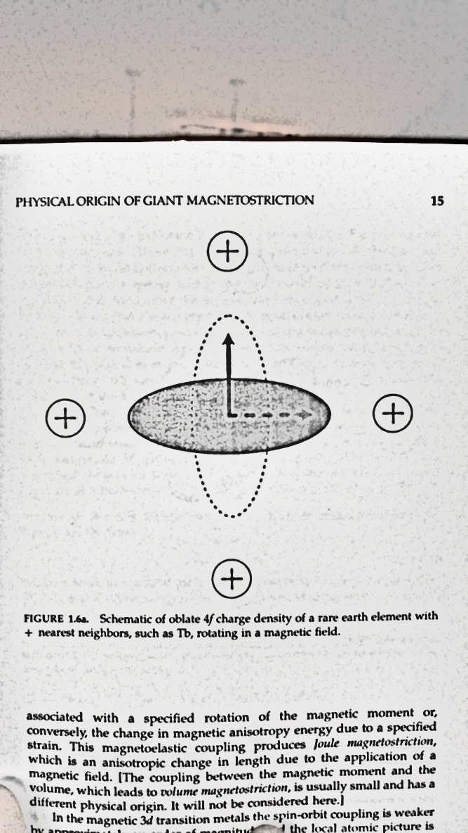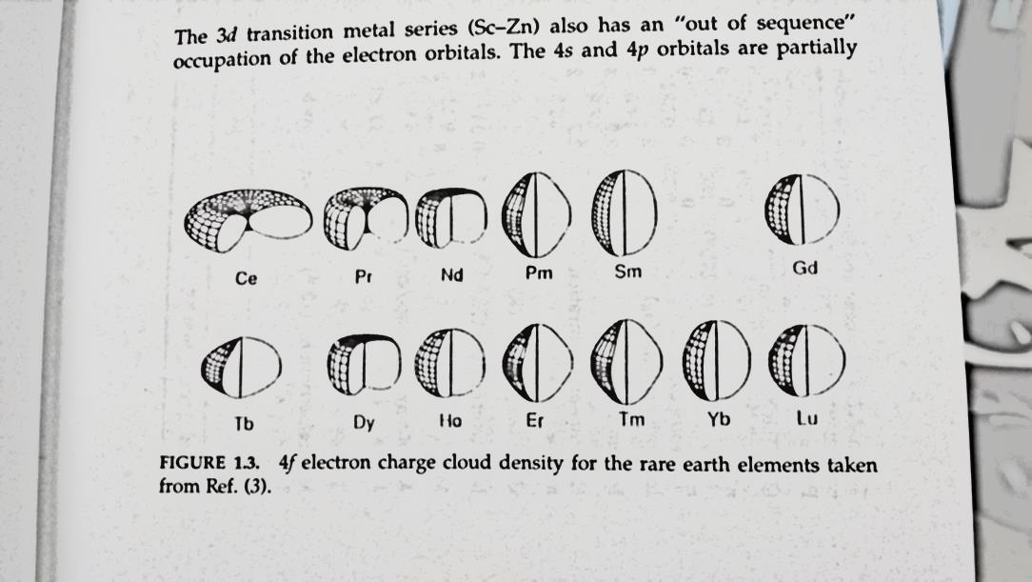

Figure : (a) 4f electron charge cloud densities for a number of rare earth elements. (b) Schematic of oblate 4f charge density of a rare earth element with + nearest neighbors, such as Tb, rotating in a magnetic field.[26]

This interaction causes ion movement which results in a macroscopic strain that can be measured at the parts per million (ppm) scale. When an applied magnetic field causes a change in the material’s magnetic moment direction, thus causing a strain from positive ion movement, this is called Joule magnetostriction named after James Prescott Joule who discovered the effect in 1842 when observing a sample of iron. The increase in length (longitudinal strain) or the contraction of diameter (lateral strain) is roughly proportional to the applied magnetic field and this can be used for various purposes in an actuator mechanism. [27]

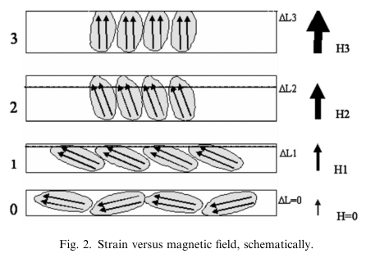

Figure : An illustration of joule magnetostriction. The magnetic moments align themselves with the applied field and cause the positive ions around them to shift and cause a strain.[27]

Another widely utilized effect related to magnetostriction is the Villari Effect. This effect is based on the fact that when a mechanical stress is imposed on a sample, there is a change in the magnetic flux density which flows through the sample as a result of the creation of a magnetic field. The change in flux density can be detected by a pickup coil and is proportional to the level of the applied stress. The Villari effect is reversible and is used in sensor applications.[27]

To quantitatively understand the contributing factors of magnetostriction, we consider a basic example of a two dimensional planar magnet, elastically isotropic in the x-y plane, with uniaxial magnetic anisotropy such that the magnetization with magnitude *Ms* prefers to lie along the x-axis[26], as seen in Figure 3. The total energy consists of energies from the Zeeman or magnetic field, uniaxial magnetic anisotropy, magnetoelastic coupling, intrinsic elastic stiffness, and coupling energy between strain and stress: $$E_{total}=E_{H}+E_{anis}+E_{me}+E_{elas}+E_{stress} \\ = -HM_{s}α_{y}-Kα_{x}^{ 2}-b\left(ε_{xx}α_{x}^{ 2}+ε_{yy}α_{y}^{ 2}+ε_{xy}α_{x}α_{y}\right)+ \\ +\left[\frac{1}{2}C_{11}ε_{xx}^{ 2}+\frac{1}{2}C_{11}ε_{yy}^{ 2}+C_{12}ε_{xx}ε_{yy}+\frac{1}{2}\left(\frac{C_{11}-C_{12}}{2}\right)ε_{xy}^{ 2}\right]-σε_{yy}$$ 
where *H* is the applied auxiliary field, $α_{y}$ is the normalized component of magnetization in the y-direction ${M_{y}}/{M_{s}}$, *K* is the energy difference between *Mx* and *My*, *b* is the magnitude of coupling, $ε_{xx}$ is the strain in the x-direction, *C11* and *C12* are independent elastic constants, and $σ$ is the applied stress. It is easy to see that if there is no magnetoelastic coupling, *b* = 0,  
the planar magnet would respond independently to field and stress. Magnetostriction is determined by measuring the change in length along some direction as the magnetization rotates. To determine the coupled response, we minimize the total energy with respect to strain and magnetization direction. Solving for the difference in $ε_{yy}$ for *M* along the y-  
direction and *M* along the x-direction: $$\frac{∆l}{l}={∆ε}_{yy}=\frac{b}{C_{11}-C_{12}}≡λ$$ 
where $λ$ is the magnetostriction constant, an effective figure of merit for magnetostrictive materials. This definition shows us the change in length along the magnetization direction that would be observed if the sample was initially magnetized perpendicular to the applied field. If a magnetic field is applied to the material at an angle to an easy axis of magnetization the material will tend to rearrange its structure so that an easy axis is aligned with the field to minimize the free energy of the system, as depicted in Figure 3. Since different crystal directions are associated with different lengths this effect induces a strain in the material. In a three dimensional isotropic material where *K* = 0, the total energy must sum all terms in the elastic strain tensor *εii* as well as the normalized magnetization direction vectors *αi*. Similar minimization to the planar example gives us the magnetostrictive strain:

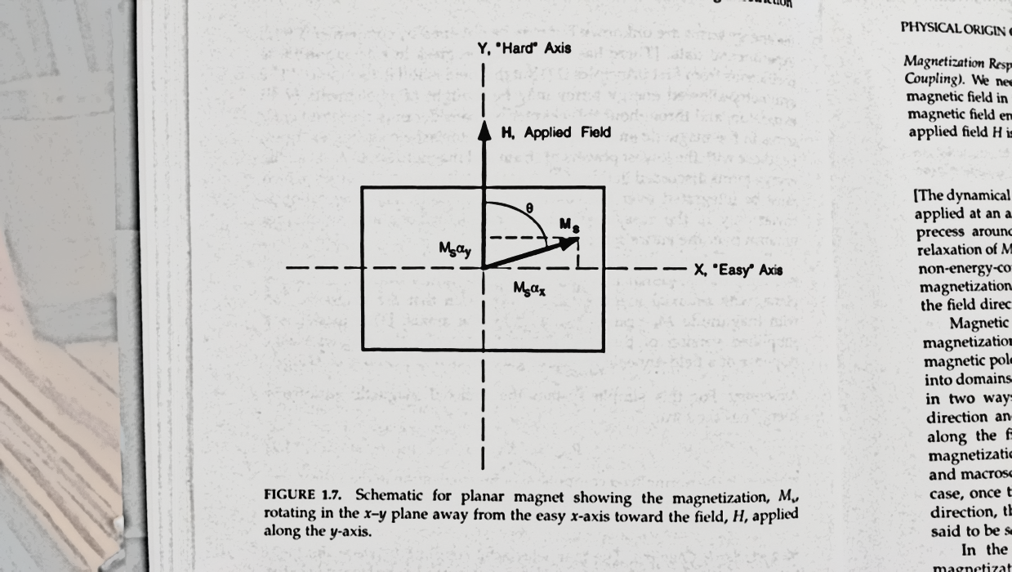

Figure : Schematic for planar magnet showing the magnetization, Ms, rotating in the x-y plane away from the easy x-axis toward the field, H, applied along the y-axis.[26]

(3)

$$\frac{∆l}{l}=\frac{b}{C_{11}-C_{12}}\left(α^{2}-\frac{1}{3}\right)≡\frac{3}{2}λ{}_{s}\left(α^{2}-\frac{1}{3}\right)$$ where *α* is the cosine of the angle between the magnetization and the measuring direction, and $λ{}_{s}$ is the saturation magnetostricition constant. Both equations make it clear that increasing the magnetoelastic coupling and decreasing the elastic constants will increase the magnetostrictive constant, but when consider the force of a magnetostrictive material (~ $λC$), a reasonable elastic constant becomes more desirable. From this observation, a rare-earth metal with its very high spin-orbit coupling would seem to be a perfect candidate for magnetostrictive applications.

As we have seen, the magnetic moments in magnetostrictive materials are already aligned in a particular direction because they are intrinsically ferromagnetic. For practical purposes, these materials like Tb and Fe have higher than normal Curie temperatures of 220 K and 1044 K, respectively. These temperatures tend to change when alloyed with other metals: Terfenol-D (TbxDy1-xFe2) has *TC* = 653 K and galfenol (FexGa1-x) has *TC* = 978 K.[28],[6] Most magnetostrictive materials are soft magnets, so they have a low coercivity. Hard magnet magnetostriction has only been seen in thin films at very low temperatures.[29], [30] This property enables easy switching of the magnetization direction for potential applications in energy harvesting.[4]

Terfenol-D (Ter for terbium, Fe for iron, NOL for Naval Ordnance Laboratory, and D for dysprosium) is a rare-earth alloy developed by Ames Laboratory in the 1980s that exhibits about 2000 ppm magnetostriction in a field of 2 kOe (160 kA/m) at room temperature. Many magnetostrictive alloy materials have been fabricated to increase saturation magnetostriction to a level of ~5000 ppm.[27] However, Table 1 shows us that Curie temperatures of magnetostrictive materials with the highest $λ{}_{s}$, like Tb0.5DyxZn1-x, are not high enough for commercial application. Terfenol-D operates at the highest saturation strain and Curie temperature than any other magnetostrictive material to date and is the most commonly used engineering magnetostrictive material.

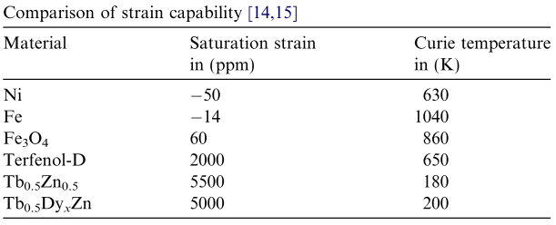

Table : This table compares the magnetostrictive strain capabilities of pure materials and alloys.[27]

For many magnetostrictive materials like Terfenol-D, there is an effect of pre-stress on the relative permeability and magnetization hysteresis. In an active magnetostrictive material the relative permeability depends on the pre-stress and the frequency used in its operation. The top plot in Figure 4 represents the magnetic behavior of Terfenol-D, and it shows how the material responds to an applied magnetic field (H) by developing a magnetic flux, with a flux density (B). The permeability is the value of B/H and the diagram shows the hysteresis loops.[27]

It is found that higher amounts of pre-stress reduce the relative permeability. For positive magnetostrictive materials an explanation for this could be that it is because when the pre-stress is high the domain movement requires more mechanical energy, and therefore the material is unable to respond to the magnetic field as well as it can when the pre-stress is lower.[27] Pre-stress does have its benefits when it comes to the magnetostrictive strain. It has been suggested that a mechanical pre-stress can cause rotations of magnetic moments in a way that they are aligned perpendicularly to this applied stress, although it is not explained why a purely mechanical factor should influence a magnetic phenomenon in this way.[27] The bottom plot of Figure 4 shows a large increase in $λ{}_{s}$ after the Terfenol-D is pre-stressed with 7 MPa of tensile stress. When a magnetic field is established in the opposite direction, the negative field produces the same elongation in the magnetostrictive material in the same way that a positive field would. The shape of the curve is aptly referred to as butterfly curves.

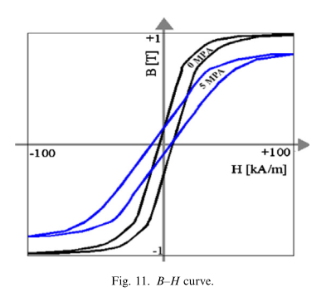

Figure : (top) The effect of pre-stress on Terfenol-D, (bottom) The effect of pre-stress on magnetostrictive hysteresis curve for Terfenol-D.[27]

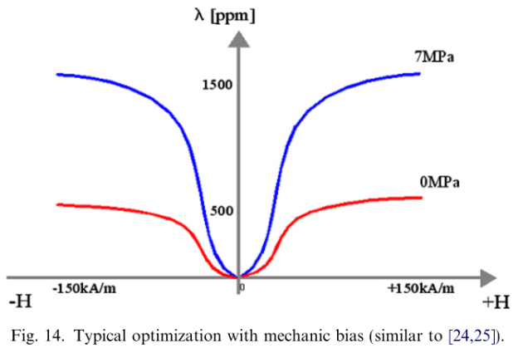

Terfenol-D attains optimum magnetostrictive properties in the form of single crystals, and since the easy axis of magnetization for Terfenol-D is <111>, it is desirable to produce single-crystal rod having such an axial orientation.[31] It is also advantageous to achieve a minimum defect concentration so that domain wall motion is not hindered by pinning mechanisms between defects and domain walls.[32] To produce these high quality single crystals, researchers and manufacturers tend to use the float-zone solidification method, FZSM, and the Bridgman method.

FZSM is a method of purifying crystals in which a narrow region of a crystal is molten. This molten zone is moved progressively along the crystal to melt the impure solid at its forward edge, leaving a wake of purer material solidified behind as it moves through the ingot, as seen in Figure 5. The end product will tend to be a single crystal if they process has full temperature control throughout this slow process. Float zone solidification is a steady state process in which the composition of the solid freezing from the zone must equal the composition of the solid being fed into the zone. Hence, if one starts with a rod of rare earth composition, *R*, greater than liquidus concentration, the solid should hold the same composition and be a mixture of RFe2 and eutectic solid.[33]

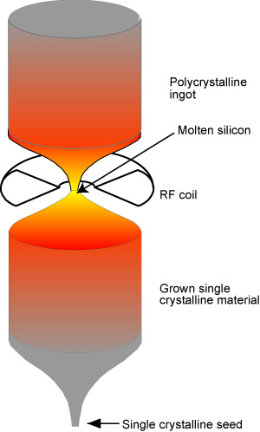

Figure : An illustration of FZSM on a silicon ingot. [Image source: http://www.pveducation.org/pvcdrom/manufacturing/float-zone-silicon]

The modified Bridgman (MB) process is similar to FZSM, except now the alloy is melted in a cylindrical ceramic crucible, and then poured via a hole in the bottom of the crucible into pre-heated molds. Again, a single crystal of the same crystallographic orientation as the seed material is grown on the seed and is progressively formed along the length of the container as the finished product is drawn out of the crucible. The process can be carried out in vertical geometry.[34] An advantage of this bottom pour configuration is that any dross which forms in the melt floats to the top and is left in the crucible on the small amount of alloy which is retained there after the pour.[31]

The FSZM method is limited to rods of 8 mm diameter maximum because the process is containerless and surface tension limits the size of the molten zone that can be generated during the process. The MB is limited to a minimum rod size of 10 mm because of side nucleation from the mold walls overwhelming the primary, axial dendritic crystal growth. [34] In both cases, secondary machining is required to generate complex geometries beyond right-angle cylinders, which can be very costly and only add to the long processing time. If these methods are sped up to meet commercial demands, they can develop many defects in the crystal structure leading to mechanical failure.[35] Terfenol-D is already very brittle in tension,[27] so the possibility of more brittle failure does not bode well for application.

Applications for the magnetostrictive properties of Terfenol-D revolve around actuators and sensors. An actuator is a type of motor that is responsible for moving or controlling a mechanism or system. It is operated by a source of energy, typically electric current, hydraulic pressure, or pneumatic pressure, and converts that energy into motion. In the case of magnetostrictive actuators, movement is controlled by a driving coil wrapped around the magnetostrictive material. Alternating current is run through the wire and the magnetic field fluctuates. The constant change in magnetic field causes a constant shape change of the magnetostrictive core and drives a vibration. Etrema designed, built, and validated a Terfenol-D actuator device, schematically shown in capable of generating seismic waves, although it can operate over a wide bandwidth of frequencies. It can generate a force of 4000 N or an acceleration of 30 g at the device’s resonant frequency of 635 Hz.[27]

The challenges for processing Terfenol-D stems from its high material cost. Terbium of 99% purity currently costs $724.50 per kg which does not count shipping rates from China.[36] China makes up about 97% of the rare mineral trade worldwide, and it is not predicted to change in the near future.[37] High temperature and high controllability of production methods contribute to the slow production and high cost of Terfenol-D and further leads to the financial impracticality of its devices. We have discussed the brittleness of Terfenol-D, which limits its ability to withstand shock loads or operate in tension.[38] Large anisotropies exhibited by rare earth metals, like terbium, are undesirable for applications because they usually require very large fields to change the direction of the magnetization.[26]

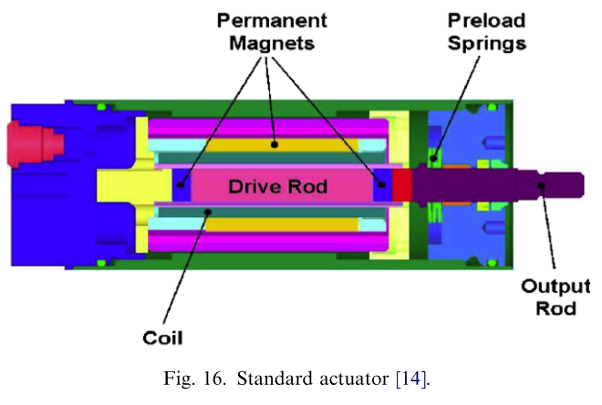

Figure : Standard actuator cross-section developed by Etrema. [27]

Galfenol, an iron-gallium alloy, has recently gained attention as an alternative to Terfenol-D because of its large magneto-mechanical coupling, low hysteresis loss, and high saturation.[39] It was another material developed by the Naval Ordnance Laboratory as an alternative to rare-earth magnetostrictive materials. The magnetostriction in galfenol arises from its 3*d-*shell spin-orbit coupling. While this is weaker than 4*f* spin-orbit coupling, galfenol has seen saturation strains up to ~400 ppm [40] under very low magnetic fields ∼100 Oe (8000 A /m). It has demonstrated high tensile strength (∼500 MPa) with limited variation in magnetomechanical properties for temperatures between −20 and 80°C.[38] Iron is a very cheap and commonly used material, and gallium is priced at $280.44 per kg, less than half of the price of bulk terbium.[36] Like Terfenol-D, galfenol was first produced by directional solidification methods, and met with the same problems of brittleness under commercially demanding production speeds. However, due to the mechanical robustness of galfenol, more conventional metal working techniques can be utilized such as ingot casting, followed by forging, extrusion, or texture rolling.

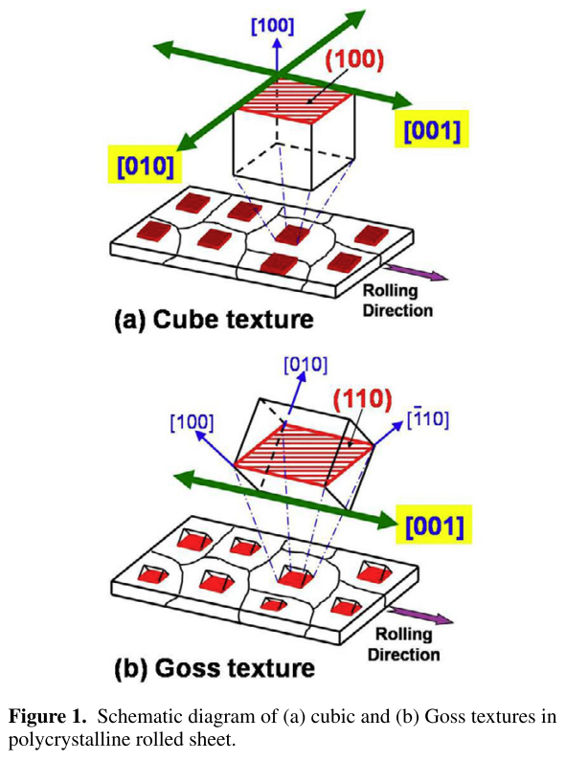

Figure : Schematic diagram of cube texture and Goss textures in a polycrystalline rolled sheet.[42]

Due to the anisotropic nature of the magnetostrictive property, the texture of the rolled galfenol sheet should align with the magnetic easy axes, <100> directions. Therefore the development of strong <100> ||RD (RD=rolling direction, ND=normal direction to the sheet surface, and TD=transverse direction) texture in the rolled sheets is critical in order to achieve maximum performance.[41] Of these textures, the {001} <100> orientation, or cube texture, is particularly desirable because it provides two <100> easy axes of magnetization in the plane of the sheet.[42] The extra benefit of developing cubic texture is that it will make it feasible to use magnetic field annealing to maximize performance[13], [15] and thereby eliminate the need for stress annealing or use of pre-stress components in the design of devices that use these materials.[16], [17] Goss textures have only one easy magnetization axis, but it much easier to grow in the rolling and annealing method than the cube texture.

This rolling and annealing technique attempts to preferentially grow abnormally large cube or Goss grain textures that maximize magnetostriction as opposed to evenly sized normal grain growth (NGG). To control abnormal grain growth (AGG), Na et al. dopes samples with sulfur or anneals in a sulfur environment to control the sulfur concentration on the surface of samples during annealing. By doing this, he has shown that sulfur segregation, which is known to control surface energy,[43] can be correlated to the selective growth of {001} grains.[44] He has also used NbC pinning particles in a mixed H2S and argon environment to halt grain growth of undesirable grains, thus abnormally growing (001) grains on 88.3% of the sample area, as seen in Figure 8.[42]

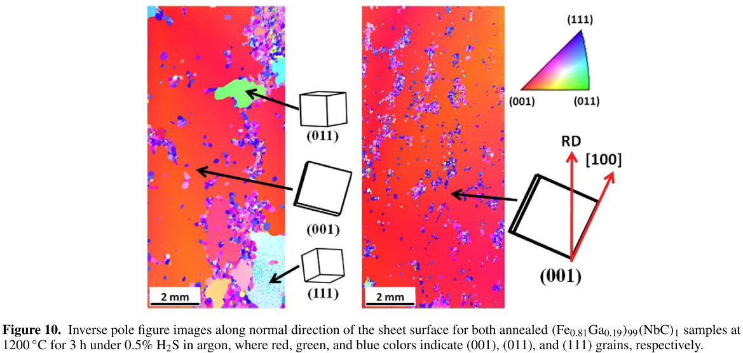

Figure : Inverse pole figure images along normal direction of the sheet surface for both annealed (Fe0.81Ga0.19)99(NbC)1 samples at 1200°C for 3 h under 0.5% H2S in argon, where red, green, and blue colors indicate (001), (011), and (111) grains, respectively.[42]

Abnormal grain growth is not very well understood and even harder to control. There have been many models, like the coincident site lattice (CSL) boundary method and high energy grain boundary (HEGB), that have tried to characterize the underlying mechanisms of AGG, but none have produced a correct formula of growth parameters for cube texture AGG. Na et al. suggests that these parameters are hidden in the surface energy of the (001), (011), and (111) grains of galfenol.

Characterization of metal surface energies are traditionally taken near their melting point,[20], [45], [46] so they cannot tell us anything about how different crystal orientations effect the surface energy. Other room temperature surface energy measurements, like grain boundary thermal grooving and liquid drop contact angles, can potentially resolve this issue. First principle studies could also be employed to find more alloying metals, besides NbC, that aid in selective AGG.[40]

### Surface Energy Review

#### Theory

1. Describing surface energy
   1. The surface energy is a measure of the energy that is necessary to break chemical bonds in order to create a new surface from a bulk solid or a liquid. It is defined as the energy necessary per unit area. The SI-Unit is therefore J/m2, and it is typically denoted as γ (gamma).
      1. Surface energy is always positive; in order to break bonds energy is always required. As every system is thermodynamically stable when its free energy is minimized, there is a tendency for surfaces with a high surface energy to minimize their area. That means, for example, that surfaces of high surface energy are easily covered by materials of low surface energy (a droplet on a surface, for example). As a rough rule of thumb, materials with strong bonds (those typically having a high melting point and high boiling point) also have high surface energy.
   2. (REWRITE BECAUSE JUST NOTES FROM [47]
      1. The surface energy across an interface or the surface tension at the interface is a measure of the energy required to form the unit area of a new surface at the interface.[47]
         1. The intermolecular bonds or cohesive bonds between molecules of a liquid cause surface tension
      2. When a liquid encounters another substance, an attraction occurs between the two materials.
         1. The adhesive forces between the liquid and the second substance will compete against cohesive forces of the liquid.
            1. **Wetting:** Liquids with weak cohesive bonds and a strong attraction to another material (or a desire to create adhesive bonds) will tend to spread over the material.
            2. **Non-wetting:** Liquids with strong cohesive bonds and weaker adhesive forces will tend to bead up or form a droplet when in contact with another material
      3. If a contact angle is measured under conditions in which the liquid drop is stationary and the surrounding conditions are in the steady state, the measured contact angle is known as the static/equilibrium contact angle.
         1. Dynamic contact angels are related to hydrodynamic conditions, whereas static contact angles depend on surface properties of the solid-liquid-vapor system under the given conditions.
   3. Notes from
2. Young’s equation
3. Broken-bond model
   1. Source for broken-bond model[48]
4. Attempts to describe Abnormal grain growth in the past[49]–[51]
   1. Coincident Site Lattice model
   2. High energy grain boundary model

### Measurement techniques

1. Scanning tunneling microscopy for measuring absolute surface energy[24]
   1. Finds absolute, orientation dependent surface energies for Pb crystallites
2. Grain boundary groove

#### Contact angle

1. Theory
   1. Equilibrium
   2. Geometric contact angle: calculate with geometric considerations only; serves as an independent variable for calculating all possible Gibbs energy states of the system
      1. For axisymmetric spherical drop (in absence of gravity) $$\frac{2-3\cos{θ}+\cos^{3}{θ}}{\sin{θ}}=\frac{3V}{πr_{b}^{2}}$$
   3. Young contact angle governed by Young’s equation: $γ_{sv}=γ_{sl}+γ_{lv}\cos{θ}$
      1. $γ_{sv}$ represents the surface tension in its equilibrium state with the fluid and liquid environments, not that of the same solid when perfectly clean under high vacuum.
      2. Sometimes it is more convenient to measure the contact angle when vapor/fluid is air, in which case $γ_{sv}$ and $γ_{lv}$ are replaced by $γ_{s}$ and $γ_{l}$, respectively.
      3. However, the value of the Young contact angle may not be directly measurable.
         1. If the line tension is not meaningful, the *actual* CA may
2. Measurement techniques
   1. Sessile drop
      1. Owens-Wendt method
         1. Polar vs. dispersive (nonpolar?) components of surface energy
         2. [52]
            1. The Owens–Wendt method (also known as the Kaelble–Owens–Wendt method) consists in determining components of dispersion and polar SFE on the basis of the Bethelot hypothesis which claims that interactions between molecules of two substances, present in their surface layer, are equal to the geometric mean of intermolecular interactions within each sub-stance. The polar component is understood as the sum of polar, hydrogen, inductive and acid–base interactions. The following equation allows one to determine the SFE [3,12]: $γ_{S}=γ_{S}^{d}+γ_{S}^{p}$ 
                  
               where $γ_{S}$ is the SFE, $γ_{S}^{d}$ is the dispersion component of SFE and $γ_{S}^{p}$ is the polar component of SFE [52]. **Inconsistent results for total SFE on aluminum plates.**
         3. [53]
            1. Owens−Wendt theory (extended Fowkes) extends on the Fowkes model by incorporating Good’s equation: $$γ_{sl}=γ_{s}+γ_{l}-2{\left(γ_{s}^{d}γ_{l}^{d}\right)}^{1/2}-2{\left(γ_{s}^{p}γ_{l}^{p}\right)}^{1/2} (5)$$ 
               where $γ_{sl}$ is the surface energy at the solid−liquid interface. Combining Young’s equation with eq 5 yields $$\frac{γ_{l}\left(\cos{θ}+1\right)}{2{\left(γ_{l}^{d}\right)}^{1/2} }={\left(γ_{s}^{p}\right)}^{1/2}\frac{{\left(γ_{l}^{p}\right)}^{1/2}}{{\left(γ_{l}^{d}\right)}^{1/2}}+{\left(γ_{s}^{d}\right)}^{1/2} (6)$$
            2. The polar and dispersive components of the liquid surface energy are known and plotting the left side of eq 6 against ${{\left(γ_{l}^{p}\right)}^{1/2}}/{{\left(γ_{l}^{d}\right)}^{1/2}}$ will produce a linear line of data points. Linear regression of the data will allow for determination of $γ_{s}^{p}$ as the square of the slope and $γ_{s}^{d}$ as the square of the y-intercept.
   2. Factors that affect the contact angle on a solid surface
      1. Drop size
      2. Temperature variance

### First Principles

#### DFT

#### Fracture Toughness

#### Graph of variance of SE with parameters

##### Variance with temperature

### Experimental Methods

#### Examples (high temp or high vacuum)

**HIGH VAC:** Alchagirov, B. B., Afaunova, L. K., Dyshekova, F. F., Taova, T. M., Arkhestov, R. K., Mozgovoi, a. G., & Kokov, Z. a. (2009). An instrument for measuring thermal characteristics of metals and alloys. Instruments and Experimental Techniques, 52(3), 447–450. doi:10.1134/S0020441209030270[54]

**HIGH TEMP THEORY:** Aqra, F., & Ayyad, A. (2012). Surface tension (γLV), surface energy (γSV) and crystal-melt interfacial energy (γSL) of metals. *Current Applied Physics*, *12*(1), 31–35. doi:10.1016/j.cap.2011.04.020 [21]

#### Examples (destructive methods)

Liquid metals for surface tension[55]

#### Experimental results

#### What’s wrong with other methods?

##### All done at high temperatures, none give SEs at room temperature

There are currently no experimental methods available to measure surface energies associated with different crystallographic orientations of metallic solid surfaces. The existing methods for metallic materials are available for measuring around their melting points, resulting in data at high temperatures. Also, the results have been estimated as an average value of possible orientations in targeted metal, i.e. isotropic property. Considering that surface energy is strongly dependent on temperature, there is a big discrepancy between the energy values at a melting point and room temperature.

Plot of measured surface energies near melting temperatures

##### Water-drop contact angle method

Gives inconsistent grain orientation specific surface energies for Fe-Ga. (Show results) Proper results should go along the lines of following paper[56]

### Our Method

Thus, to overcome shortcoming of existing methods, we develop capability that employs measurement of contact angles and size of a drop of liquid metal, gallium, which has a melting point of ~30o, resting on a metal surface as the metal is heated. Changes in surface tension will be introduced by controlled thermal expansion of the metal substrate. Measurement will be performed at temperature ranging ~30-100oC to give mobility to the molten gallium drop and on oriented metal surfaces.

#### Experimental apparatus

INSERT SECTION FROM ANNUAL REPORT

## Theory of our method

### Dr. Wu’s theory calculations

# Our results

### Thermal Grooving

### Ga contact angle measurements

# Our model using thermal expansion

# Possible simulations

**References**

[1] G. Raghunath, A. B. Flatau, S.-M. Na, and B. Barkley, “Development of a Bio-Inspired Tactile Magnetostrictive Whisker Sensor Using Alfenol,” in *Volume 2: Mechanics and Behavior of Active Materials; Integrated System Design and Implementation; Bioinspired Smart Materials and Systems; Energy Harvesting*, 2014, p. V002T04A012.

[2] J. L. Gonzalez, A. Rubio, and F. Moll, “Human powered piezoelectric batteries to supply power to wearable electronic devices,” *Int. J. Soc. Mater. Eng. Resources*, vol. 10. pp. pp. 34–40, 2002.

[3] C. R. Saha, T. O&apos;Donnell, N. Wang, and P. McCloskey, “Electromagnetic generator for harvesting energy from human motion,” *Sensors Actuators, A Phys.*, vol. 147, no. 1, pp. 248–253, 2008.

[4] T. Ueno and S. Yamada, “Performance of energy harvester using iron-gallium alloy in free vibration,” *IEEE Trans. Magn.*, vol. 47, no. 10, pp. 2407–2409, 2011.

[5] A. E. Clark, K. B. Hathaway, M. Wun-Fogle, J. B. Restorff, T. a. Lograsso, V. M. Keppens, G. Petculescu, and R. a. Taylor, “Extraordinary magnetoelasticity and lattice softening in bcc Fe-Ga alloys,” *J. Appl. Phys.*, vol. 93, no. 10, p. 8621, 2003.

[6] A. E. Clark, M. Wun-Fogle, J. B. Restorff, and T. a. Lograsso, “Magnetostrictive Properties of Galfenol Alloys Under Compressive Stress.,” *Mater. Trans.*, vol. 43, no. 5, pp. 881–886, 2002.

[7] T. Ueno and S. Yamada, “Technical Information: Vibrational Energy Harvester using Magnetostrictive Material,” 2015. [Online]. Available: http://vibpower.w3.kanazawa-u.ac.jp/research-e.html.

[8] S.-M. Na, M. Rice, G. Raghunath, V. Klimchenko, and A. B. Flatau, “Magnetostrictive Alfenol Whisker Sensor Performance and Sensitivity to Whisker Thickness,” *IEEE Trans. Magn.*, vol. 50, no. 11, pp. 1–4, Nov. 2014.

[9] J.-H. Yoo and A. B. Flatau, “A bending-mode galfenol electric power harvester,” *J. Intell. Mater. Syst. Struct.*, vol. 23, no. 6, pp. 647–654, Feb. 2012.

[10] S.-M. Na and A. B. Flatau, “Temperature dependence of abnormal grain growth and high magnetostriction in Goss-oriented Fe-Al thin sheets,” *J. Appl. Phys.*, vol. 115, no. 17, p. 17A913, May 2014.

[11] S.-M. Na and A. B. Flatau, “Texture evolution and probability distribution of Goss orientation in magnetostrictive Fe – Ga alloy sheets,” *J. Mater. Sci.*, vol. 49, no. 22, pp. 7697–7706, 2014.

[12] S.-M. Na and A. B. Flatau, “Global Goss grain growth and grain boundary characteristics in magnetostrictive Galfenol sheets,” *Smart Mater. Struct.*, vol. 22, no. 12, p. 125026, Dec. 2013.

[13] J.-H. Yoo, S.-M. Na, J. B. Restorff, M. Wun-Fogle, and A. B. Flatau, “The Effect of Field Annealing on Highly <newline/>Textured Polycrystalline Galfenol Strips,” *IEEE Trans. Magn.*, vol. 45, no. 10, pp. 4145–4148, Oct. 2009.

[14] M. Brooks, E. Summers, J. B. Restorff, and M. Wun-Fogle, “Behavior of magnetic field–annealed Galfenol steel,” *J. Appl. Phys.*, vol. 111, no. 7, p. 07A907, 2012.

[15] J.-H. Yoo, J. B. Restorff, M. Wun-Fogle, and A. B. Flatau, “The effect of magnetic field annealing on single crystal iron gallium alloy,” *J. Appl. Phys.*, vol. 103, no. 7, p. 07B325, Feb. 2008.

[16] J. B. Restorff, M. Wun-Fogle, A. E. Clark, and K. B. Hathaway, “Induced Magnetic Anisotropy in Stress-Annealed Galfenol Alloys,” *IEEE Trans. Magn.*, vol. 42, no. 10, pp. 3087–3089, Oct. 2006.

[17] E. Summers, R. Meloy, and J. B. Restorff, “Galfenol alloying additions and the effects on uniaxial anisotropy generation,” *J. Appl. Phys.*, vol. 106, no. 2, p. 024914, Jul. 2009.

[18] H. P. Bonzel, “3D equilibrium crystal shapes in the new light of STM and AFM,” *Phys. Rep.*, vol. 385, no. 1–2, pp. 1–67, 2003.

[19] I. Egry, G. Lohoefer, and G. Jacobs, “Surface Tension of Liquid Metals: Results from Measurements on Ground and in Space,” *Phys. Rev. Lett.*, vol. 75, no. 22, pp. 4043–4046, 1995.

[20] I. Egry, E. Ricci, R. Novakovic, and S. Ozawa, “Surface tension of liquid metals and alloys--recent developments.,” *Adv. Colloid Interface Sci.*, vol. 159, no. 2, pp. 198–212, Sep. 2010.

[21] F. Aqra and A. Ayyad, “Surface tension (γLV), surface energy (γSV) and crystal-melt interfacial energy (γSL) of metals,” *Curr. Appl. Phys.*, vol. 12, no. 1, pp. 31–35, Jan. 2012.

[22] Y. Xia, Y. Xiong, B. Lim, and S. E. Skrabalak, “Shape-Controlled Synthesis of Metal Nanocrystals : Simple Chemistry Meets Complex Physics?,” *Angew. Chemie Int. Ed.*, vol. 48, no. 1, pp. 60–103, 2009.

[23] S. J. Park, S. Kim, S. Lee, Z. G. Khim, K. Char, and T. Hyeon, “Synthesis and magnetic studies of uniform iron nanorods and nanospheres,” *J. Am. Chem. Soc.*, vol. 122, no. 35, pp. 8581–8582, 2000.

[24] C. Bombis, A. Emundts, M. Nowicki, and H. P. Bonzel, “Absolute surface free energies of Pb,” *Surf. Sci.*, vol. 511, no. 1–3, pp. 83–96, 2002.

[25] F. Breu, S. Guggenbichler, and J. Wollmann, “Handbook of Giant Magnetostrictive Materials,” *Vasa*, 2008.

[26] G. Engdahl, *Handbook of Giant Magnetostrictive Materials*, 1st ed. San Diego, CA: Academic Press, 1999.

[27] a. G. Olabi and A. Grunwald, “Design and application of magnetostrictive materials,” *Mater. Des.*, vol. 29, no. 2, pp. 469–483, 2008.

[28] I. Etrema Products, “What is Terfenol-D?,” 2012. [Online]. Available: http://www.etrema.com/core/terfenold/.

[29] T. Kakeshita, T. Takeuchi, T. Fukuda, M. Tsujiguchi, T. Saburi, R. Oshima, and S. Muto, “Giant magnetostriction in an ordered Fe[sub 3]Pt single crystal exhibiting a martensitic transformation,” *Appl. Phys. Lett.*, vol. 77, no. 10, p. 1502, Sep. 2000.

[30] C. Prados, I. Panagiotopoulus, G. C. Hadjipanayis, J. J. Freijo, and A. Hernando, “High magnetostriction in low applied magnetic fields in amorphous Tb-Fe (hard)/Fe-B (soft) multilayers,” *IEEE Trans. Magn.*, vol. 33, no. 5, pp. 3712–3714, 1997.

[31] J. D. Verhoeven, E. D. Gibson, O. D. Mcmasters, and J. E. Ostenson, “Directional Solidification and Heat Treatment of TerfenoI-D Magnetostrictive Materials,” *Metall. Trans. A*, vol. 21, no. August, pp. 2249–2255, Aug. 1990.

[32] J. D. Verhoeven, E. D. Gibson, O. D. McMasters, and H. H. Baker, “The growth of single crystal Terfenol-D crystals,” *Metall. Trans. A*, vol. 18, no. 2, pp. 223–231, Feb. 1987.

[33] O. D. McMasters, J. D. Verhoeven, and E. D. Gibson, “Preparation of Terfenol-D by float zone solidification,” *J. Magn. Magn. Mater.*, vol. 54–57, pp. 849–850, Feb. 1986.

[34] J. Snodgrass and O. D. McMasters, “Optimized TERFENOL-D manufacturing processes,” *J. Alloys Compd.*, vol. 258, pp. 24–29, 1997.

[35] “Direct conversation with Dr. Suok-Min Na.” 2015.

[36] MetalPrices.com, “Current Terbium Price,” *Argus Media*, 2014. [Online]. Available: http://www.metalprices.com/metal/terbium/terbium-metal-ex-china. [Accessed: 01-Jan-2015].

[37] A. King, “Analysts shrug off rare earth trade ruling,” *Chemistry World*, 2014. [Online]. Available: http://www.rsc.org/chemistryworld/2014/04/analysts-shrug-rare-earth-trade-ruling. [Accessed: 30-Apr-2015].

[38] J. Atulasimha and A. B. Flatau, “A review of magnetostrictive iron–gallium alloys,” *Smart Mater. Struct.*, vol. 20, no. 4, p. 043001, 2011.

[39] T. Ueno and T. Higuchi, “Magnetic circuit for stress-based magnetic force control using iron-gallium alloy,” *IEEE Trans. Magn.*, vol. 43, no. 6, pp. 2594–2596, 2007.

[40] Y. Zhang and R. Wu, “Mechanism of large magnetostriction of galfenol,” *IEEE Trans. Magn.*, vol. 47, no. 10, pp. 4044–4049, 2011.

[41] E. M. Summers, R. Meloy, and S.-M. Na, “Magnetostriction and texture relationships in annealed galfenol alloys,” *J. Appl. Phys.*, vol. 105, no. 7, p. 07A922, 2009.

[42] S. M. Na and a B. Flatau, “Surface-energy-induced selective growth of (001) grains in magnetostrictive ternary Fe–Ga-based alloys,” *Smart Mater. Struct.*, vol. 21, no. 5, p. 055024, May 2012.

[43] J. L. Walter, “Control of Texture in Magnetic Material by Surface Energy,” *J. Appl. Phys.*, vol. 36, no. 3, pp. 8–15, 1965.

[44] S.-M. Na and A. B. Flatau, “Secondary recrystallization, crystallographic texture and magnetostriction in rolled Fe–Ga based alloys,” *J. Appl. Phys.*, vol. 101, no. 9, p. 09N518, 2007.

[45] F. Aqra and A. Ayyad, “Surface energies of metals in both liquid and solid states,” *Appl. Surf. Sci.*, vol. 257, no. 15, pp. 6372–6379, May 2011.

[46] C. Cao, L. Zhang, X. Bai, L. Duan, and F. Wang, “Measurement of surface tension and specific heat of Ni-18.8 at.% Si alloy melt by containerless processing,” *J. Mater. Sci.*, vol. 46, no. 19, pp. 6243–6247, Apr. 2011.

[47] S. Park and M.-K. Seo, *Interface Science and Composites*. Academic Press, 2011.

[48] J. K. Mackenzie, A. J. W. Moore, and J. F. Nicholas, “Bonds broken at atomically flat crystal surfaces—I,” *J. Phys. Chem. Solids*, vol. 23, no. 3, pp. 185–196, Mar. 1962.

[49] H. Chun, S.-M. Na, C. Mudivarthi, and A. B. Flatau, “The role of misorientation and coincident site lattice boundaries in Goss-textured Galfenol rolled sheet,” *J. Appl. Phys.*, vol. 107, no. 9, p. 09A960, 2010.

[50] H. Chun, S.-M. Na, J.-H. Yoo, M. Wuttig, and A. B. Flatau, “Tension and strain annealing for abnormal grain growth in magnetostrictive Galfenol rolled sheet,” *J. Appl. Phys.*, vol. 109, no. 7, p. 07A941, 2011.

[51] H. Chun, “Abnormal grain growth in magnetostrictive galfenol rolled sheet,” 2011.

[52] A. Rudawska and E. Jacniacka, “Analysis for determining surface free energy uncertainty by the Owen–Wendt method,” *Int. J. Adhes. Adhes.*, vol. 29, no. 4, pp. 451–457, Jun. 2009.

[53] A. Kozbial, Z. Li, C. Conaway, R. McGinley, S. Dhingra, V. Vahdat, F. Zhou, B. D’Urso, H. Liu, and L. Li, “Study on the surface energy of graphene by contact angle measurement.,” *Langmuir*, 2014.

[54] B. B. Alchagirov, L. K. Afaunova, F. F. Dyshekova, T. M. Taova, R. K. Arkhestov, a. G. Mozgovoi, and Z. a. Kokov, “An instrument for measuring thermal characteristics of metals and alloys,” *Instruments Exp. Tech.*, vol. 52, no. 3, pp. 447–450, Jun. 2009.

[55] J. Lee, A. Kiyose, S. Nakatsuka, M. Nakamoto, and T. Tanaka, “Improvements in Surface Tension Measurements of Liquid Metals Having Low Capillary Constants by the Constrained Drop Method,” *ISIJ Int.*, vol. 44, no. 11, pp. 1793–1799, May 2004.

[56] S. G. Wang, E. K. Tian, and C. W. Lung, “Surface energy of arbitrary crystal plane of bcc and fcc metals,” *J. Phys. Chem. Solids*, vol. 61, no. 8, pp. 1295–1300, 2000.

[57] B. J. Slaughter, E. Summers, and E. Products, “Galfenol Energy Harvesting,” *ETREMA Propr.*, no. 515, pp. 1–7, 2011.

1. A. G. Khachaturyan and D. Viehland, “*Structurally Heterogeneous Model of Extrinsic Magnetostriction for Fe-Ga and Similar Magnetic Alloys: Part I. Decomposition and Confined Displacive Transformation*”, Metall. Mater. Trans. A 38, 2308 (2007).
2. A. G. Khachaturyan and D. Viehland, “*Structurally Heterogeneous Model of Extrinsic Magnetostriction for Fe-Ga and Similar Magnetic Alloys: Part II. Giant Magnetostriction and Elastic Softening*”, Metall. Mater. Trans. A 38, 2317 (2007).